**Step Function**

**Task#1**

Create 3 different lambda functions to perform start, stop and terminate EC2 instance.

-Create a step function to pass inputs

-If start input is passed then invoke your start EC2 lambda function.

- If stop input is passed then invoke your stop EC2 lambda function.

- If terminate input is passed then invoke your terminate EC2 lambda function.

Step1) Create 3 different lambda functions for start, stop and terminate ec2 instance.

StartEC2 lambda function

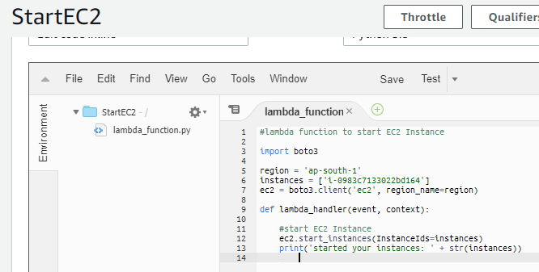

Stop EC2 instance lambda function

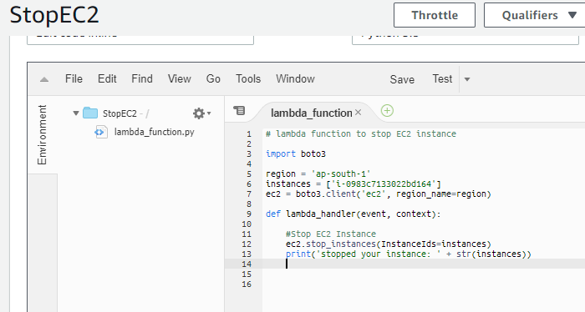

Terminate EC2 instance lambda function

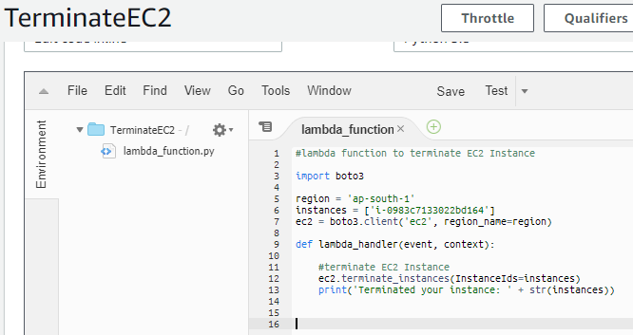

Step 2) Create a step function to give input and invoke lambda function accordingly

After creation of step functions execute them.

Currently Instance is in Stopped State

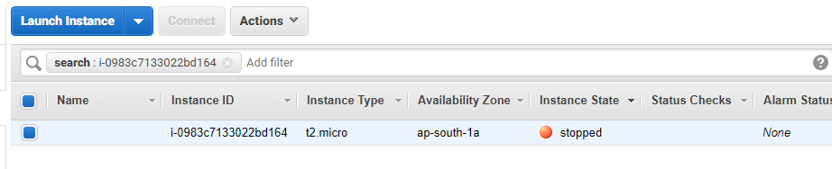

Execute step function and give input as ‘start’ to invoke start ec2 lambda function

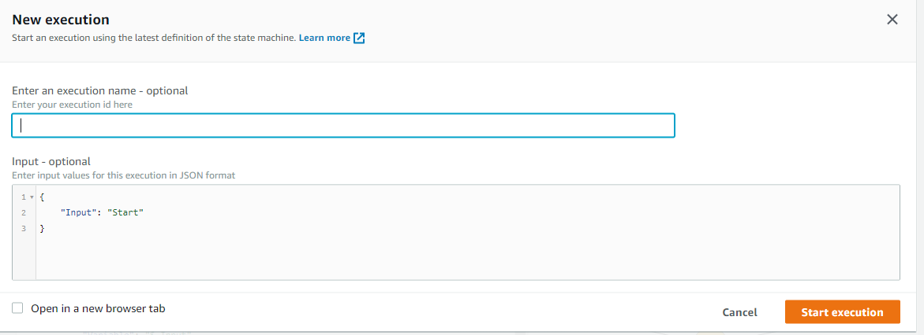

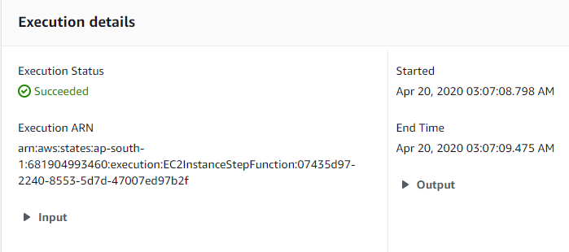

Execution of lambda function is a success.

Now lets check the status of EC2 instance

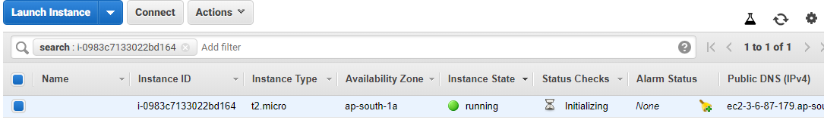

Now lets try to stop the EC2 instance

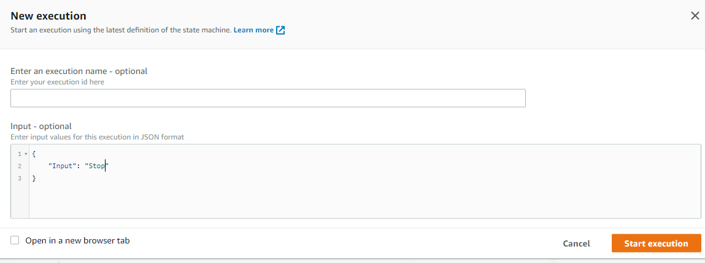

The instance has stopped

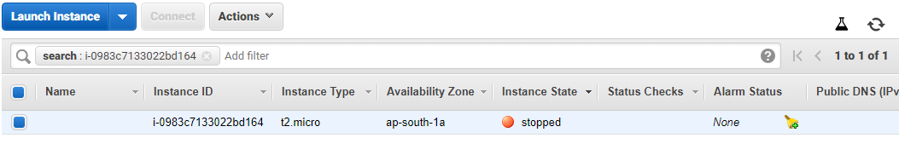

Now lets terminate the EC2 instance

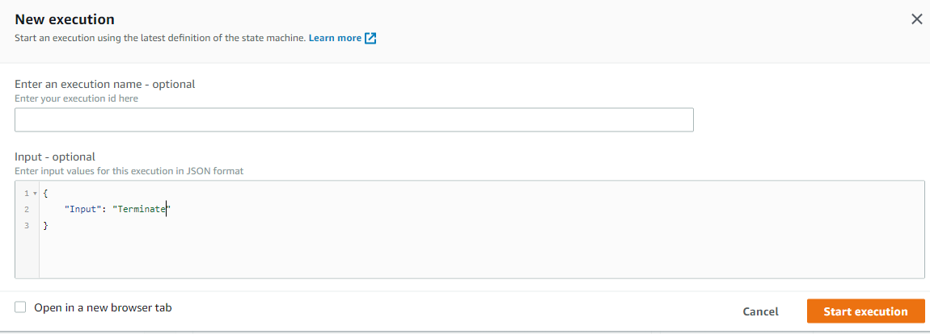

Now the instance has terminated.

